BANK PROSPECT DATA ANALYSIS USING AWS

Manoj Mahinish Rajaboina
Surraj Kumar Venkatesh Prabhu

INTRODUCTION:
Prospecting the bank data plays an important role in the success of the bank sector in which bank prospect enables the customers who are potential and used to implement the marketing strategies Effectively. In today’s world competition with high data driven aspects businesses should have to access a large amount of data i.e., information which can be utilized to discover valuable information.

The bank prospecting data analysis has many major aspects to identify the potential customers which related to finding the right customers, increasing conversion rates which gives clear information about the increase in sales. This also focuses on customizing marketing messages, which is personalizing marketing which enhances business. The next most important strategy to prospect the bank data is to know about optimizing the sales and other marketing strategies. Prospecting the data of the bank can also give information that enhances the customer experience. By this we can understand how to use data effectively by taking smart decisions and growing the company in the world of high competition in businesses.
In this project the bank prospecting data is analyzed and later the data visualization was done in tabulae with different aspects and later the data deployed in tabulae online which is a server to store and to show the data which was visualized as a log. Later the data is going to be modelled using different Machine learning algorithms which can predict the different parameters. Here, we are going to predict the loan approval status of the customers who applied for the loan.
This project is implemented in two versions with two different approaches. Version one is implemented with server-less service i.e., AWS Athena and the second version is implemented using the AWS EMR (Elastic Map Reduce) which will use cluster and instance for data processing.

FUNCTIONALITY:
The functionality of the project bank prospect data includes data collection, data analysis, data visualization, Data deployment, predictive modelling, and data security.
Data collection:
The bank prospect dataset is leveraged from ChatGPT as we don’t get the bank data from any other sources because privacy is one of the most important things about the data of customers for any bank. So, we made our decision to leverage the dataset from ChatGPT. The dataset includes information about the customer details which includes the age, salary, gender, country, number of dependents, home ownerships, Employment, Martial Status, credit card, loan intent, loan amount, loan interest rate, loan status, loan percent income, person credit history length (duration of the credit card).

Data Analysis:
The data analysis implemented in two different approaches in this project. The project has two versions one is implement cluster serverless service which uses AWS Athena and another version implemented using AWS EMR which creates the clusters and instance for data processing. In both the versions the queries are implemented accordingly to get the data analysis as required.

Data visualization:
The data visualization is implemented to the data set which we got from the query which is implemented in the data analysis. In this project tabulae used for data visualization. In tabulae the dataset is imported accordingly, and visualization can be done by selecting different wanted columns. Here, in this project we implemented and visualized the country along with the loan amount and credit card length.

Data Deployment:
Visualized data deployed in the tabulae server which makes different users access and to check the data visualization from any part of the world by just logging into the tabulae server. In this we can also create personal server windows to deploy visualized data.

Predictive Modeling:
The implemented query dataset is used to predict the different factors which are required or mentioned. In this project as we are dealing with the bank prospect, we can just predict the loan approval by using different factors like house ownership and credit history. In this we are going to use the classification models to predict the parameters mentioned.

Data Security:
In this project data security is one of the major constraints to safeguard the customer’s data and privacy. In each part of the project, we have different data security policies to protect the data of the customers. In the data processing or analysis part we have the AWS services to protect the data. In AWS there is an IAM which is an identity and access management which gives different features of the User Access management, access control and MFA which is a multi-factor authentication.
In the remaining parts like data visualization and data deployment which is a tabulae related service which are tabulae desktop and tabulae server. In tabulae server also has authentication and access control of data with high encryption and it has data recovery and backup for the data.

DESIGN OF THE PROJECT:
The design of the project has two versions accordingly based on the approach. The flow chart can give the overview and overall design of the project.

VERSION 1:
Generating a Bank Prospect Dataset from ChatGPT and Cleaning the dataset.
5
Selecting a Data Set
Uploading the dataset to s3 bucket
Data extraction, transformation, and load
Query the data.
Data visualization
By using AWS CLI dataset from local machine is imported to AWS S3 bucket.
The data will be extracted, transferred, and loaded (ETL) using glue. Crawler is used to create metadata table to load data from s3 and it will store back data in glue data catalog and again glue data stores the data back in s3 in the format in which Athena can read the data.
Visualizing the data using Tabulae.
The data will be transformed using AWS Athena for queries. The Athena will access data through glue data catalog which is a central metadata repository.

VERSION 2:

5
Generating a Data Set
Creation of AWS Glue Crawler for ETL Processing
Setup in AWS Athena
Importing the dataset from local to S3 via AWS CLI
Creation and starting of EMR Cluster (Spark Code)
Model Prediction using Jupyter Notebook
Data Visualization in Tableau
Deployment in Tableau Online

DEPLOYMENT CONSIDERATIONS:
The project has many deployment considerations in which mainly focuses on data security and compliance, data portioning and organization, optimization of query, performance, scalability, meta data management, backup recovery management, data integration, data logging and monitoring ML prediction modeling and data visualization can view as a log on server on desktop in either windows or mac.

STEPS TO RUN THE APPLICATION:

AWS CLI Setup:
Step 1: aws (To check AWS is installed in local)

Step 2: aws Configure (To set the key ID, Region, Output format)

AWS Access Key ID [****************5DIT]:
AWS Secret Access Key [****************XXy4]:
Default region name [us-west-1]:
Default output format [json]:

Step 3: aws s3 cp s3://C:/Users/surrajkumar2000/Downloads/dataset.csv s3://bankdata 2/dataset.csv

Step 4: aws s3 ls (To display the files in the s3 bucket)

AWS EMR:
Step 1: Sign in to the AWS Management Console using AWS credentials and navigate to the Amazon EMR service.

Step 2: Click on "Create cluster" to start the cluster creation process.

Step 3: Configure cluster details:
a. Provide a name for the cluster.
b. Choose whether to enable logging for your cluster.
c. Select the launch mode (On-Demand or Spot Instances).
d. Choose the instance types for the master and core nodes.
e. Specify the number of instances for the master and core nodes.
f. Select the VPC and subnet for your cluster.
g. Configure security settings and specify an EC2 key pair.

Step 4: Configure cluster hardware:
a. Set up additional options related to hardware settings, such as instance groups, EBS volumes, and instance fleets.

Step 5: Define the input data location:
a. Specify the location of your input data in Amazon S3 or other supported storage systems.

Step 6: Configure permissions:
a. Set up the necessary IAM roles and policies to grant permissions to your cluster.

Step 7: Monitor the cluster:
a. Once the cluster is launched, you can monitor its status and progress from the Amazon EMR console.
b. Use the console to view logs, track metrics, and manage the cluster.

AWS Glue Setup:
Step 1: Sign into the AWS Management Console and navigate to AWS Glue.
Step 2: Set up an IAM role to grant AWS Glue access to resources.
Step 3: Create or select a Glue Data Catalog to store metadata information.
Step 4: Define data sources such as Amazon S3, JDBC-compatible databases, or DynamoDB.
Step 5: Use Glue crawlers to automatically discover and catalog metadata about your data sources.
Step 6: Create ETL jobs to transform and move data, either visually or through code.
Step 7: Schedule and run jobs on a specific frequency or trigger them manually.

AWS Athena Setup:
Step 1: Navigate to the Amazon Athena service in the AWS Management Console.
Step 2: Configure settings like creating a workgroup and specifying a query result location.
Step 3: Define tables by creating them manually or using Glue crawlers to automatically create them.
Step 4: Write SQL-like queries in Athena's query editor to analyze and retrieve data from the tables.
Step 5: Monitor query performance and optimize queries for better efficiency.

AWS Sagemaker Setup:
Step 1: Sign into the AWS Management Console: Go to the AWS Management Console (https://console.aws.amazon.com) and sign in using your AWS credentials.

Step 2: Navigate to the Amazon SageMaker service.

Step 3: Set up an IAM role: Create or use an existing IAM role with the necessary permissions for SageMaker to access resources.

Step 4: Create an Amazon SageMaker notebook instance:
a. Provide a name for the notebook instance.
b. Choose an instance type for the notebook instance.
c. Specify the IAM role you created earlier.
d. Create the notebook instance.

Step 5: Access the notebook instance:
a. Click on "Open Jupyter" or "Open JupyterLab" to launch the Jupyter notebook interface.
b. Start creating and running notebooks for your machine learning tasks.

Tableau Setup:
Step 1: Install Tableau Desktop: Download and install Tableau Desktop from the Tableau website.

Step 2: Launch Tableau Desktop: Open Tableau Desktop on your machine.

Connect to Athena:
a. Click on "Connect to Data" or navigate to the "Connect" pane.
b. Select "Amazon Athena" as the data source.
c. Enter the Athena endpoint URL, database name, S3 staging directory, and authentication details.
d. Click "Sign In" to establish the connection.

Authenticate with AWS:
- Enter your AWS Access Key ID and Secret Access Key or use IAM roles for authentication.

Create a Tableau data source:
a. Select the desired schema and tables from the available options.
b. Click "Connect" to create the data source.

Build visualizations:
- Use Tableau's drag-and-drop interface to create visualizations and analyze the data from Athena.

Publish and share:
- Publish the Tableau workbook to Tableau Server or Tableau Online for sharing and collaboration.

TEST RESULTS:

Implementation:

PySpark Code:

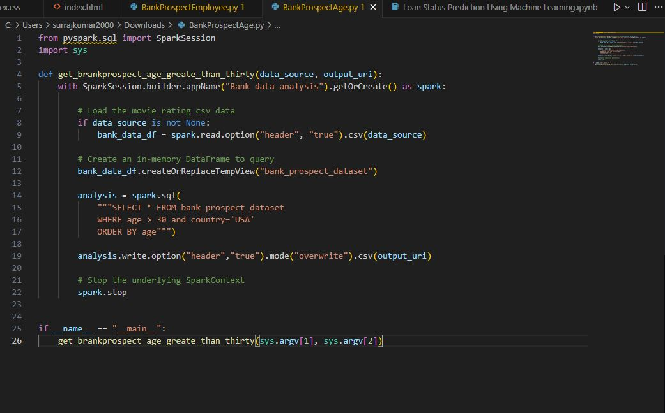

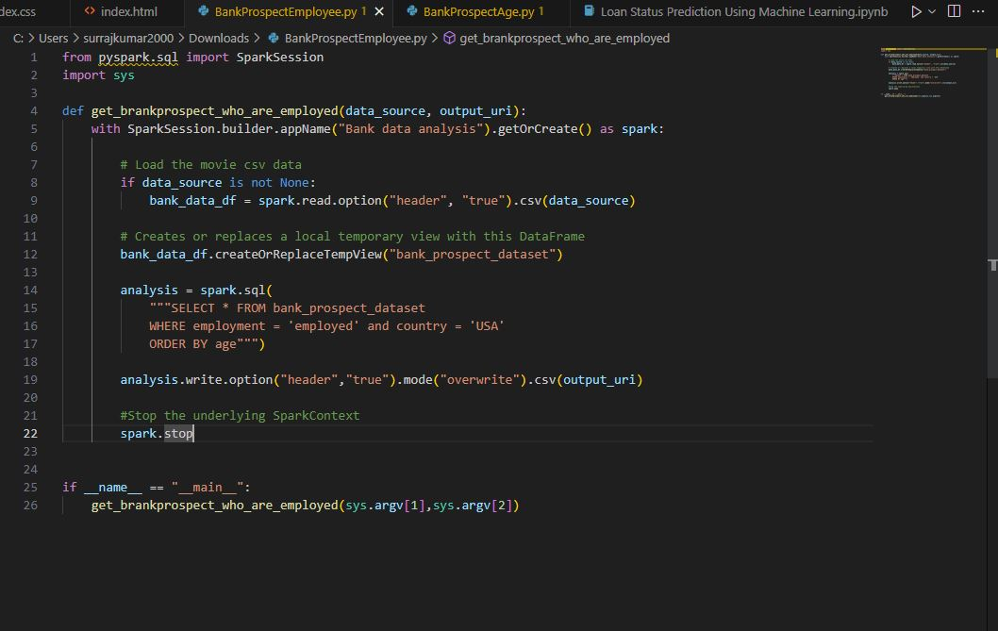

AWS CLI SETUP:

- In our project, we are using the AWS CLI (Command Line Interface) to import the dataset from the local machine to the AWS S3 bucket.

- Since the main objective of our project is to make an end-to-end flow, this setup will help automate the process.

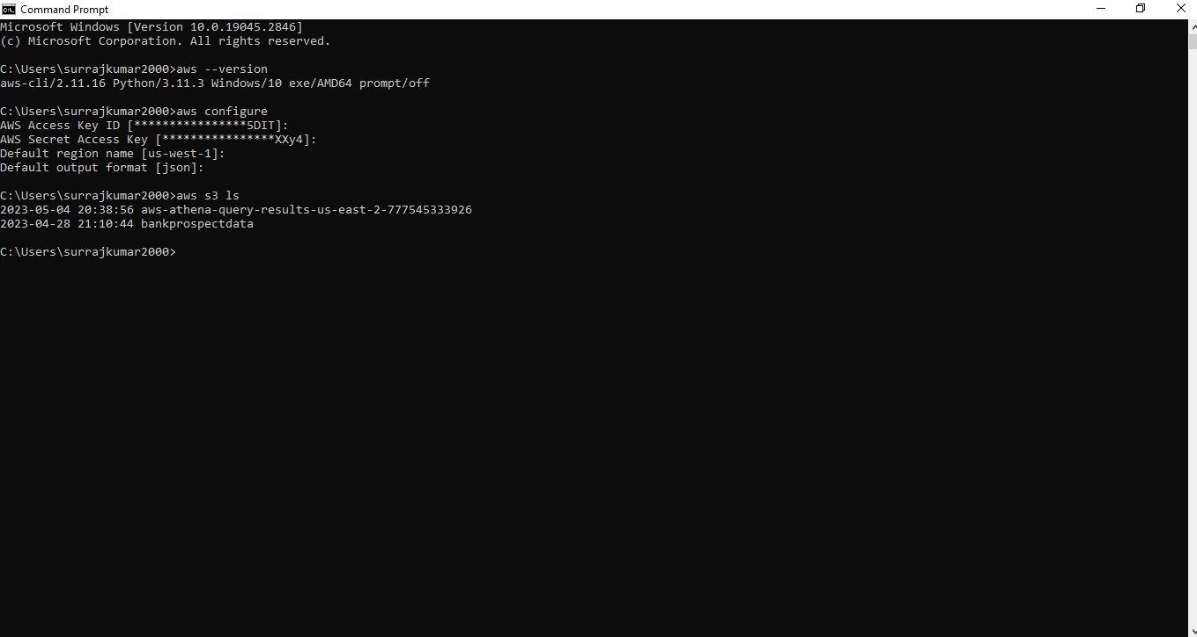

AWS S3 Bucket Setup:

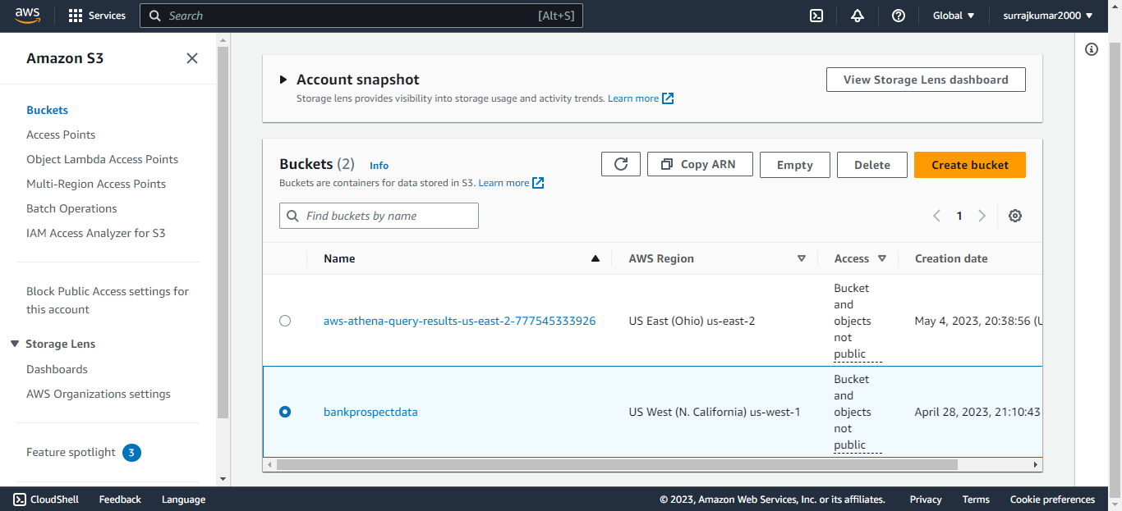

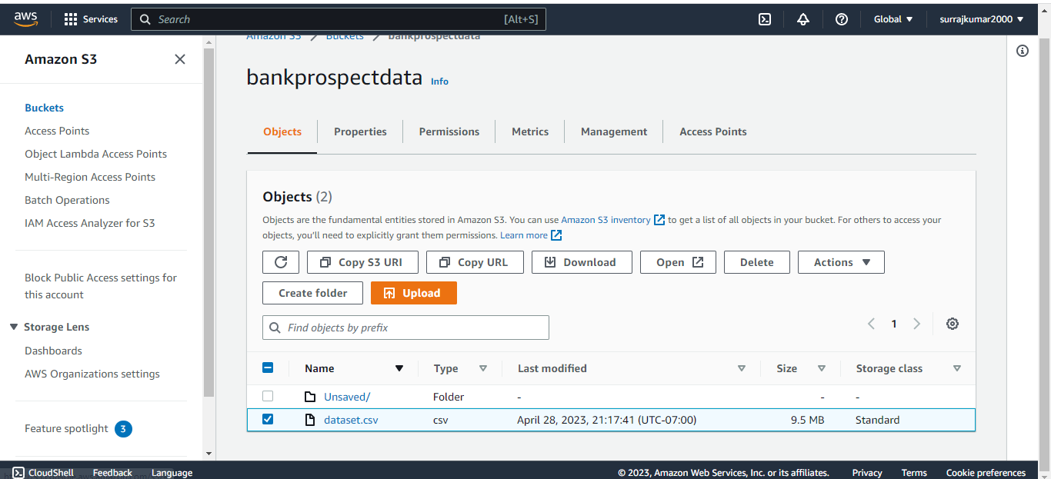

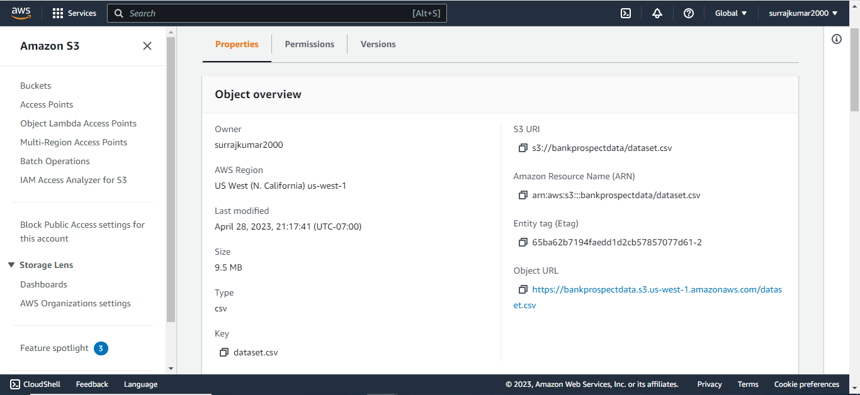

AWS Glue Setup:

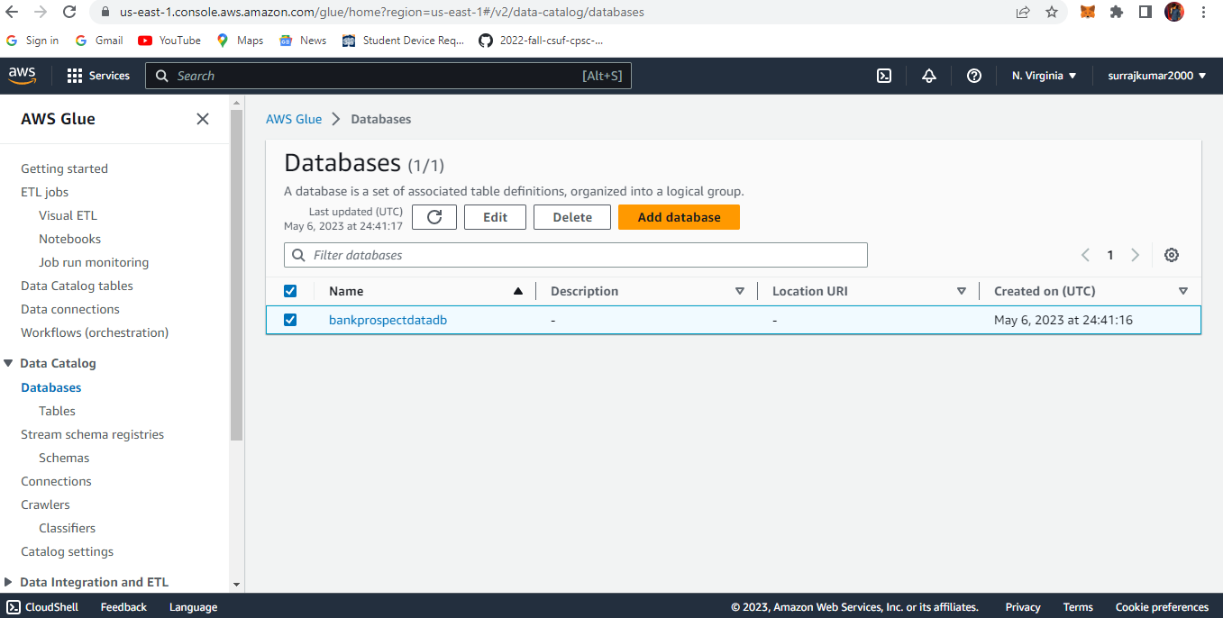

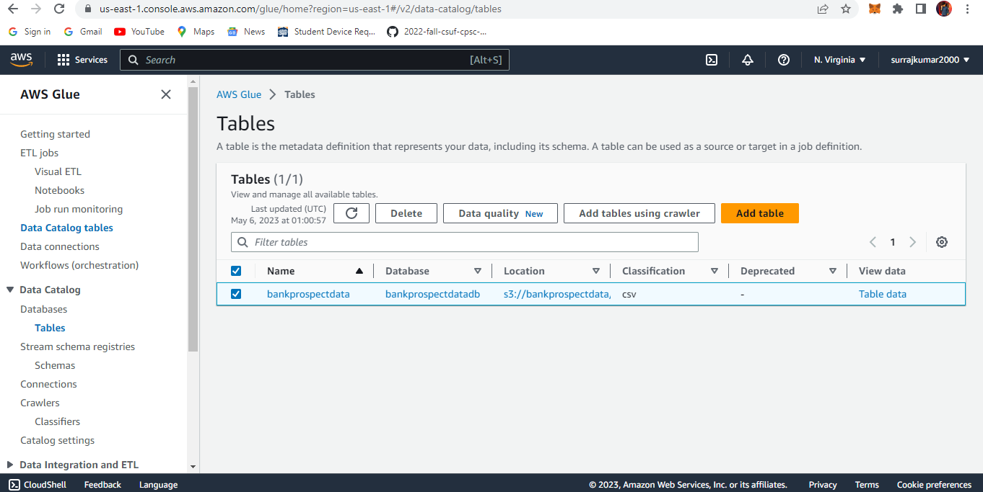

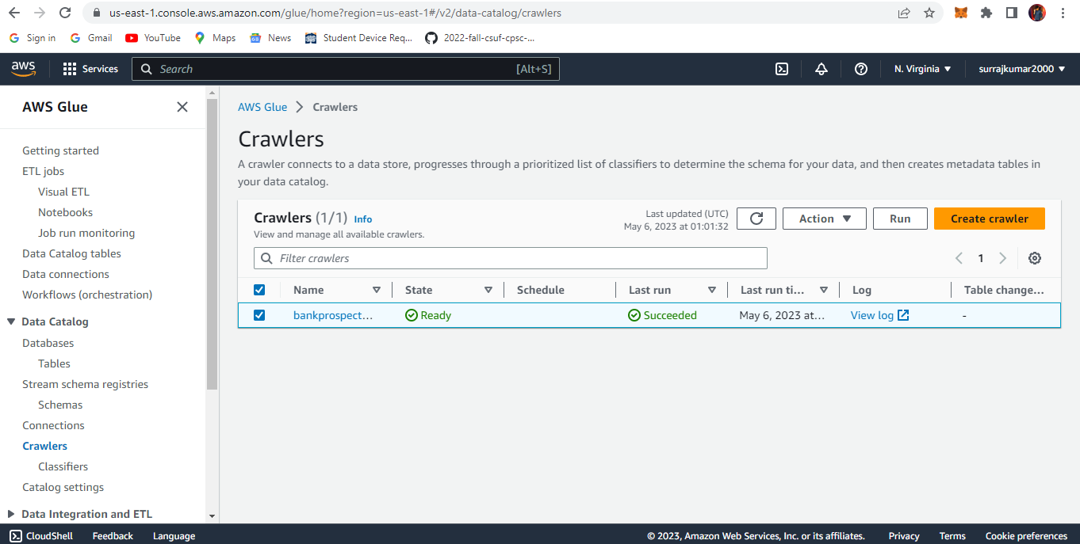

AWS Athena:

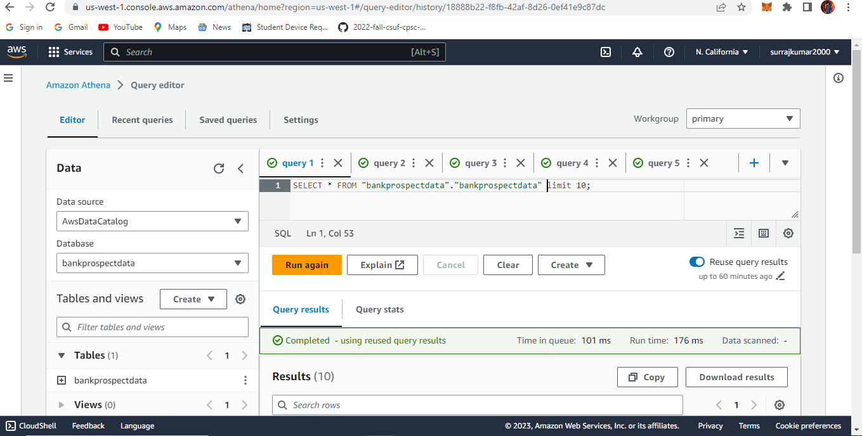

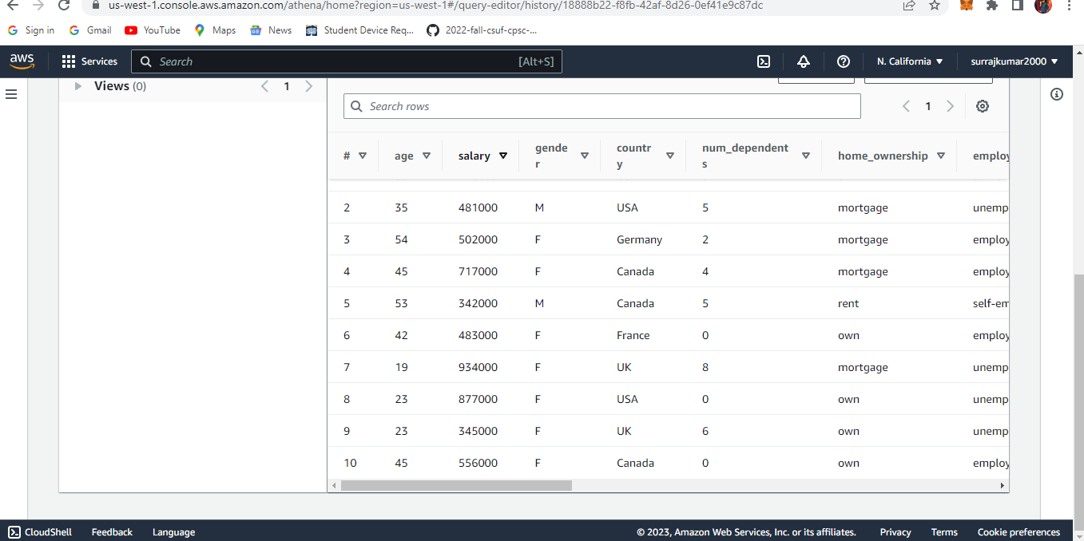

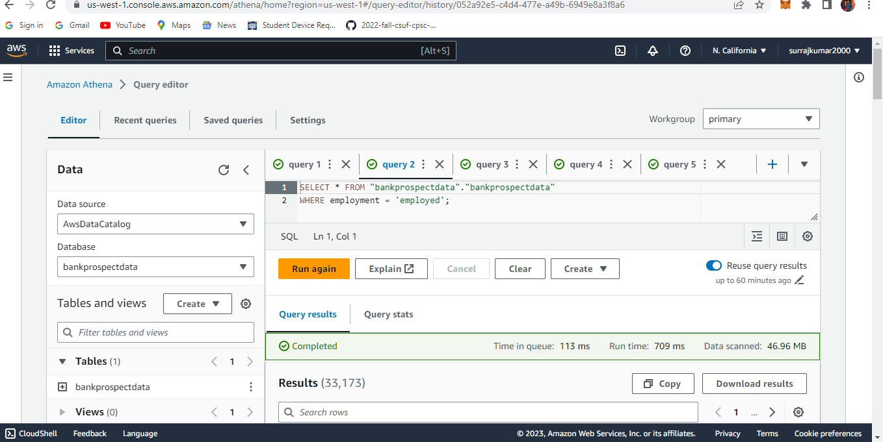

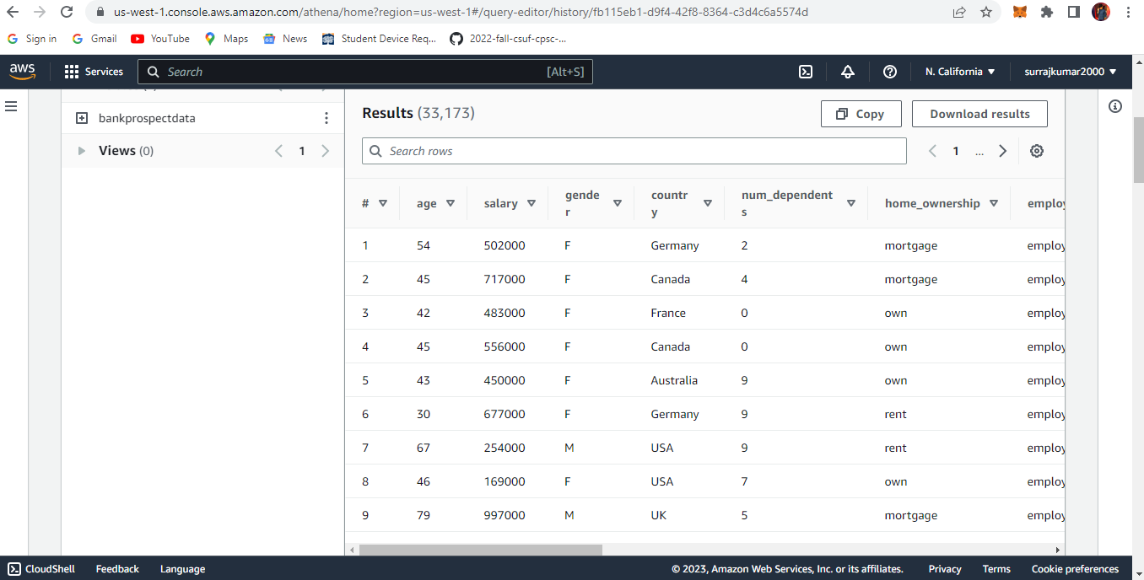

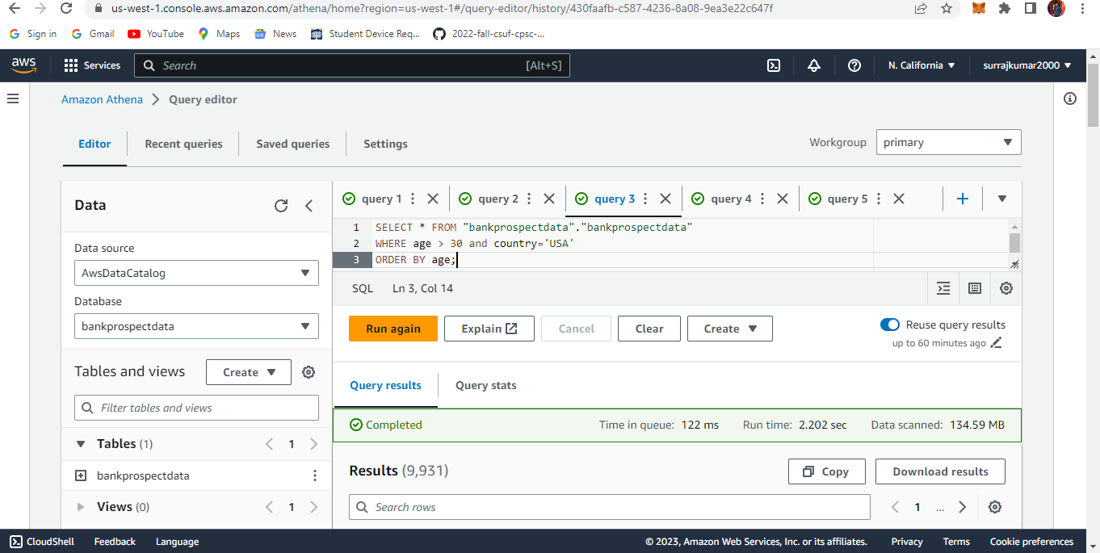

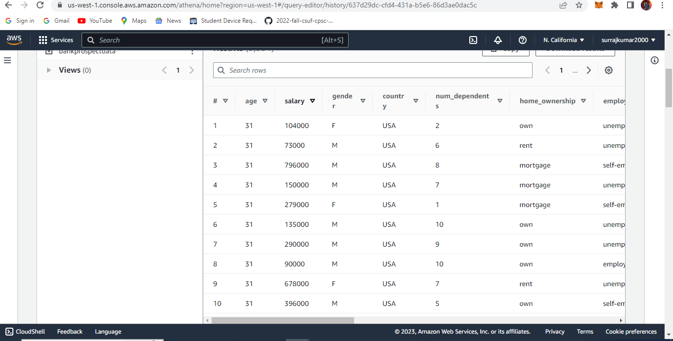
Data visualization Tabulae:

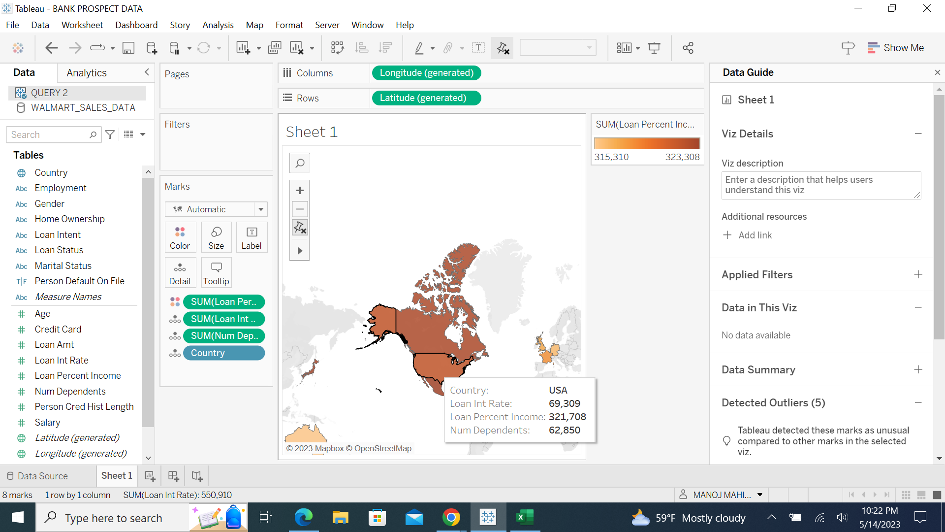

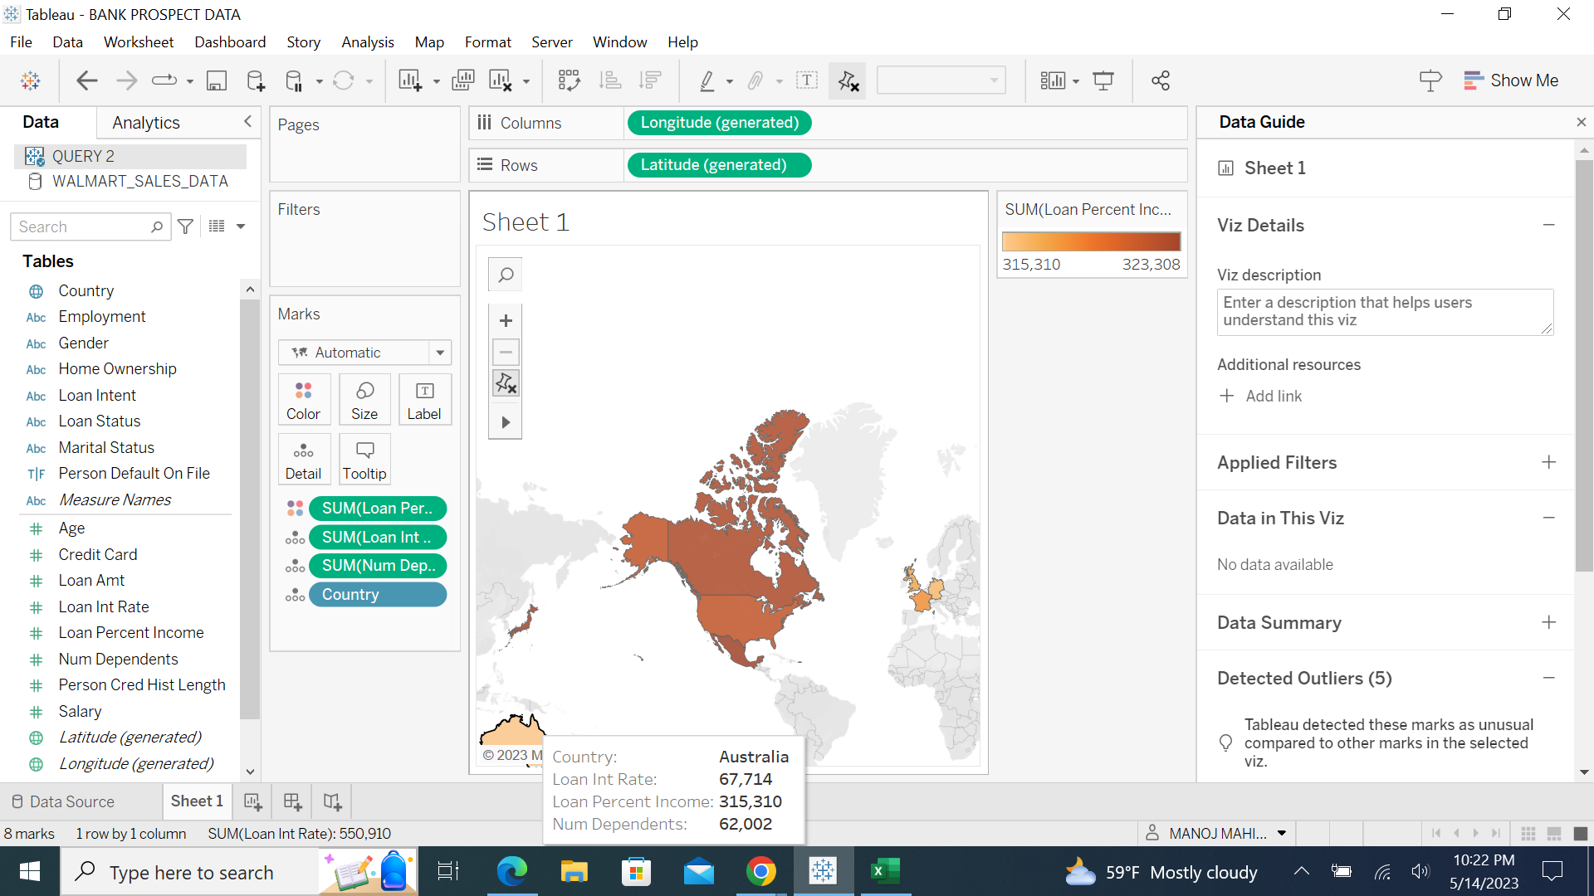
Model Prediction:

